**8. Introduction to Terragrunt configuration file**

* let us understand what is the terragrunt configuration file? In this current configuration file, we have to understand what is an extension, what language we have to use, what is the order that we have to follow, what parameters we need to write inside the file, and how to format a file if we have written some syntax errors and all. So let us see that one by one in the configuration file.
* we must remember the extinction of the file will be. hcl (hashicorp configuration language)
* So, we will be using that extinction and we will be writing the terragrunt configuration file and the data which you write inside this configuration file. It uses the same hcl syntax. What we have seen in the TerraForm.
* In the TerraForm, we have learned Hashicorp configuration language in order to create a resource on the target provider. So, we must adopt the same thing.
* We do not need to learn a new language to write that a configuration file, so we will be using the same language.

--- **terragrunt hclfmt**

* So, this command will format your terragrunt configuration files and remember, this command will search in a recursive order.

--- **terragrunt hclfmt --terragrunt-check**

Just I want to check the syntax, but I do not want to overwrite my file. So, for that option they are providing **--terragrunt-check**.

**Terraform configuration file**

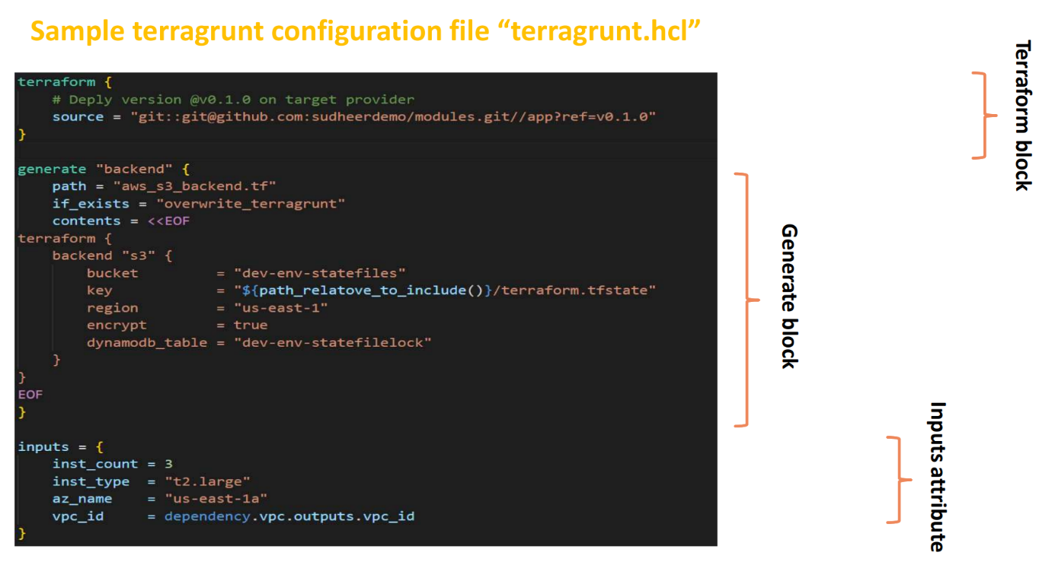

In the sample configuration file, I have written only a few blocks later in the session we will see what are the blocks that we can write or attributes we can write in the current configuration file. For now, I have written only three blocks here to understand or to show you that what is a configuration file and how it looks.

**Terraform block**

You can see here we have written something called TerraForm BLOCK here.

It is a TerraForm BLOCK. So here we will write something where we have written our TerraForm configuration files. So, you can see here my TerraForm configuration files are stored under this repository.

**Terraform configuration block**

